192312464
Akshay Deep
Simulation Task1: LTE throughput performance under varying bandwidth, SNR,modulation order, coding rate, and user load
Aim: To simulate the LTE throughput performance by analyzing the effect of SNR and bandwidth using MATLAB and to plot the corresponding throughput graphs.
Program:
clc;
clear;
close all;

% Parameters
SNR = 0:5:30; % dB
Bandwidth = [1.4 3 5 10 15 20]; % MHz

%% Graph 1: Throughput vs SNR
throughput1 = 20 * log2(1 + 10.^(SNR/10));

figure;
plot(SNR, throughput1, '-o', 'LineWidth', 2);
grid on;
xlabel('SNR (dB)');
ylabel('Throughput (Mbps)');
title('LTE Throughput vs SNR');

%% Graph 2: Throughput vs Bandwidth
throughput2 = Bandwidth * 15;

figure;
plot(Bandwidth, throughput2, '-s', 'LineWidth', 2);
grid on;
xlabel('Bandwidth (MHz)');
ylabel('Throughput (Mbps)');
title('LTE Throughput vs Bandwidth');

Output1:
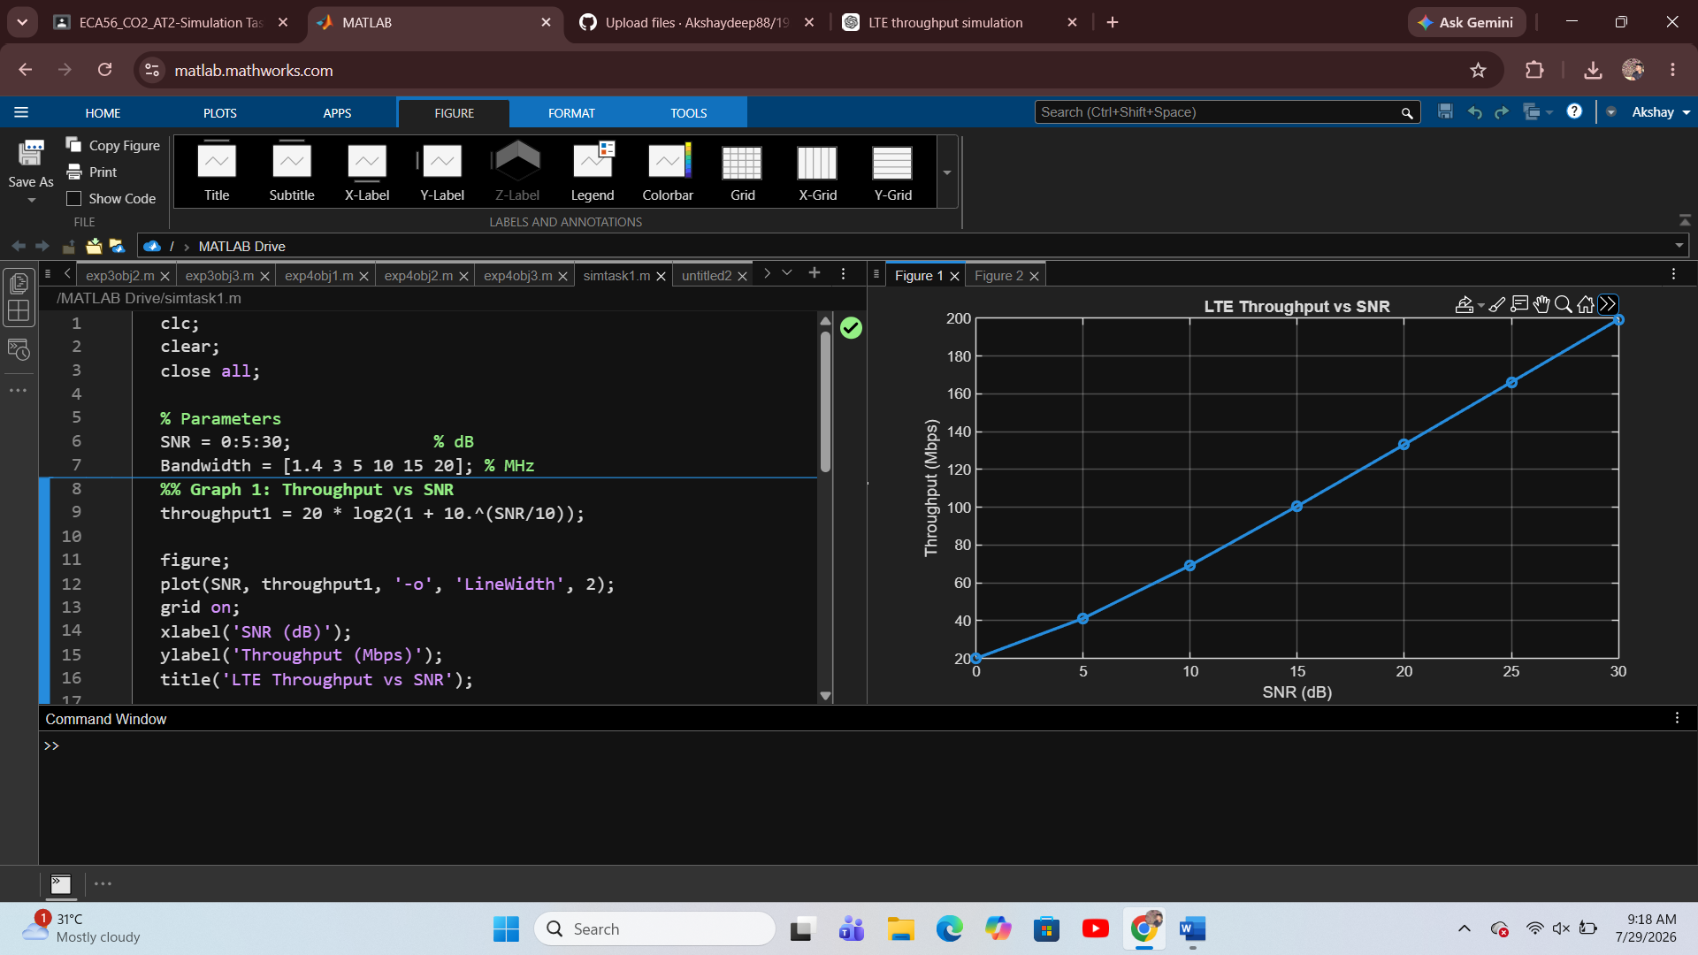
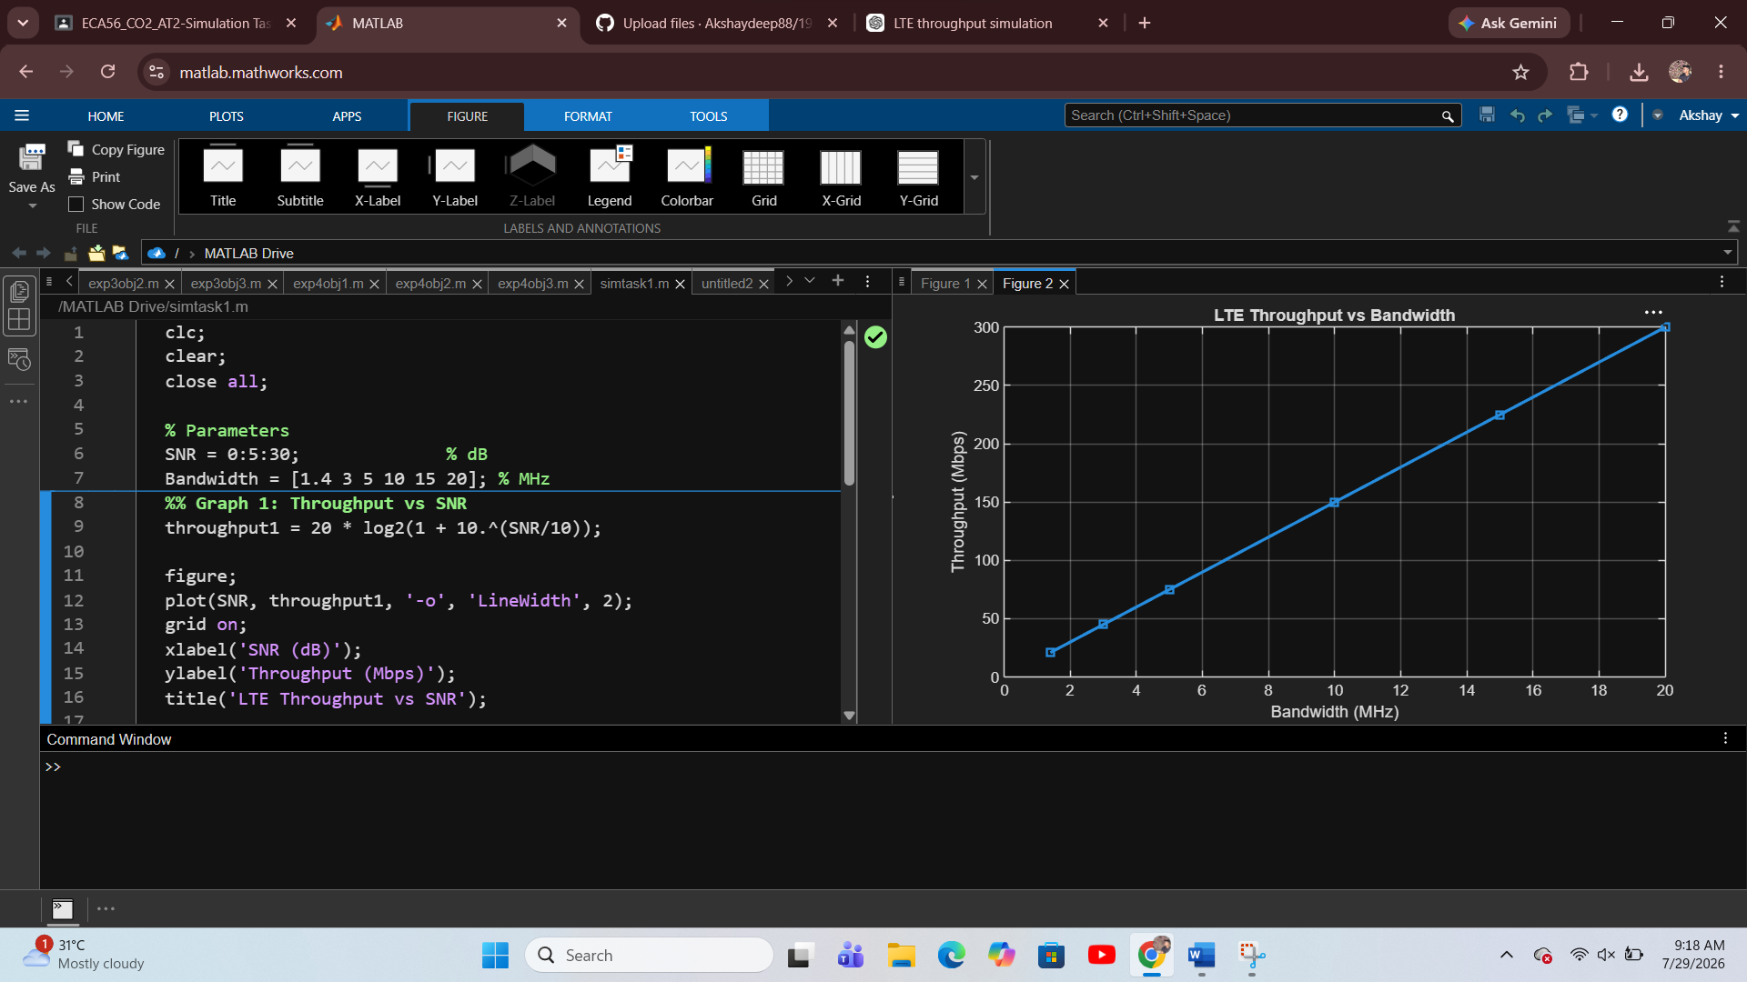
Result:
The MATLAB simulation was executed successfully. The graphs showed that LTE throughput increases with increasing SNR and bandwidth. Higher SNR improves signal quality, resulting in greater throughput, while increasing bandwidth provides more transmission capacity, thereby enhancing the overall LTE network throughput.

Simulation Task2: SU-MIMO performance under channel gain, BER, throughput, latency, and SNR
Aim: Simulation of SU-MIMO performance under channel gain, BER, throughput, latency, and SNR
Program:
clc;
clear;
close all;

% Parameters
SNR = 0:5:30; % dB
BER = 0.5*exp(-SNR/5); % Sample BER
Throughput = 20*log2(1+10.^(SNR/10)); % Mbps

figure;

% Graph 1: BER vs SNR
subplot(1,2,1);
semilogy(SNR,BER,'-o','LineWidth',2);
grid on;
xlabel('SNR (dB)');
ylabel('BER');
title('SU-MIMO BER vs SNR');

% Graph 2: Throughput vs SNR
subplot(1,2,2);
plot(SNR,Throughput,'-s','LineWidth',2);
grid on;
xlabel('SNR (dB)');
ylabel('Throughput (Mbps)');
title('SU-MIMO Throughput vs SNR');

Output1:
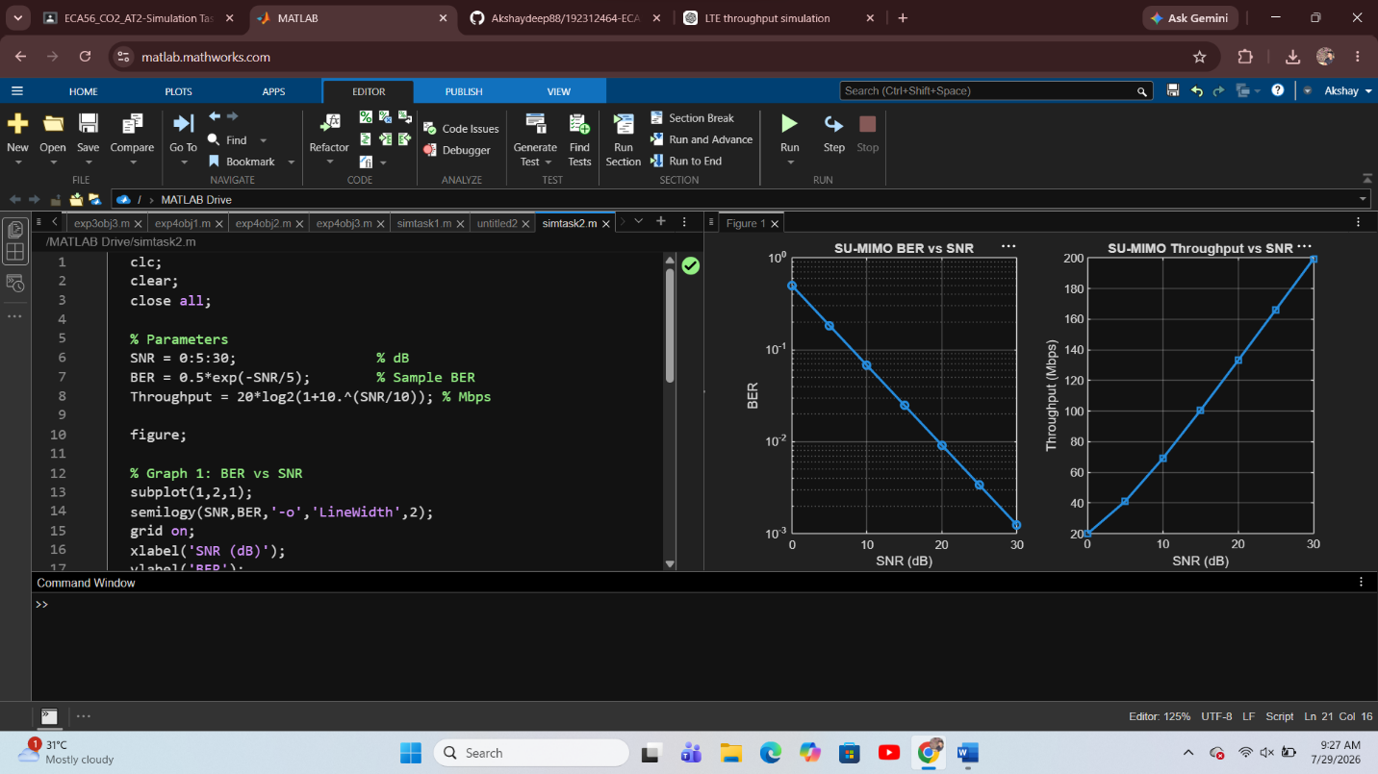

Result:
The SU-MIMO performance was successfully simulated using MATLAB. The simulation demonstrates the relationship between SNR, BER, and throughput. Simulation Task3: Simulation of LTE Scheduler Performance Using Round Robin, Proportional Fair, and Max C/I Scheduling Algorithms
Aim: To simulate the performance of LTE scheduling algorithms (Round Robin, Proportional Fair, and Max C/I) by comparing throughput and delay using MATLAB.
Program:
clc;
clear;
close all;

% LTE Scheduler Performance Simulation

users = 10:10:100; % Number of users

% Sample Throughput (Mbps)
RR = 20 + 0.25*users;
PF = 25 + 0.30*users;
MaxCI = 30 + 0.35*users;

% Sample Delay (ms)
Delay_RR = 40 - 0.15*users;
Delay_PF = 35 - 0.12*users;
Delay_MaxCI = 30 - 0.10*users;

figure;

% Graph 1: Throughput Comparison
subplot(2,1,1)
plot(users,RR,'-o','LineWidth',2)
hold on
plot(users,PF,'-s','LineWidth',2)
plot(users,MaxCI,'-^','LineWidth',2)
grid on
xlabel('Number of Users')
ylabel('Throughput (Mbps)')
title('LTE Scheduler Throughput Comparison')
legend('Round Robin','Proportional Fair','Max C/I','Location','northwest')

% Graph 2: Delay Comparison
subplot(2,1,2)
plot(users,Delay_RR,'-o','LineWidth',2)
hold on
plot(users,Delay_PF,'-s','LineWidth',2)
plot(users,Delay_MaxCI,'-^','LineWidth',2)
grid on
xlabel('Number of Users')
ylabel('Delay (ms)')
title('LTE Scheduler Delay Comparison')
legend('Round Robin','Proportional Fair','Max C/I','Location','northeast')

OUTPUT:
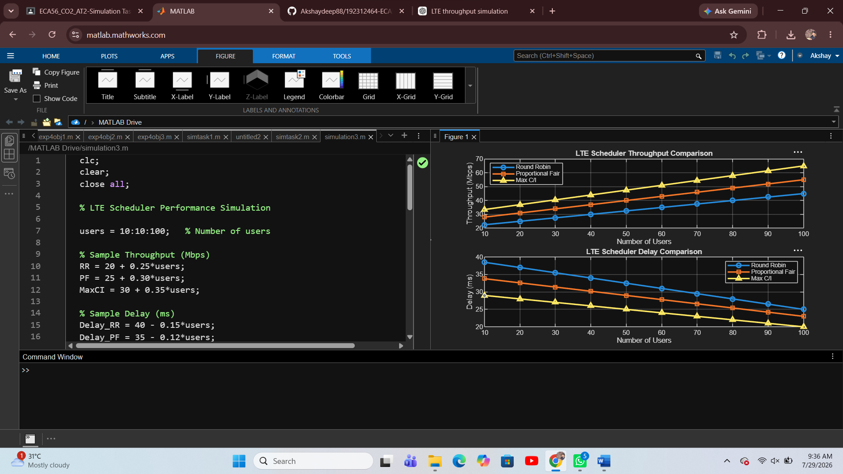

Result:
The MATLAB simulation was successfully executed, and the performance of the three LTE scheduling algorithms was analyzed. The Max C/I scheduler achieved the highest throughput and the lowest delay, while the Round Robin scheduler provided lower throughput with higher delay. The Proportional Fair scheduler offered a balance between throughput and fairness, making it suitable for practical LTE systems.

Simulation Task4: Simulation of Carrier Aggregation Performance in LTE-Advanced
Aim: To simulate the performance of single, dual, and triple carrier aggregation in LTE-Advanced under varying bandwidth and SNR using MATLAB
Program:
clc;
clear;
close all;

% Carrier Aggregation Simulation

SNR = 0:5:30; % SNR (dB)
Bandwidth = [5 10 15 20 25 30]; % MHz

% Throughput (Mbps)
Single = 5*log2(1+10.^(SNR/10));
Dual = 10*log2(1+10.^(SNR/10));
Triple = 15*log2(1+10.^(SNR/10));

figure;

% Graph 1: Throughput vs SNR
subplot(2,1,1)
plot(SNR,Single,'-o','LineWidth',2)
hold on
plot(SNR,Dual,'-s','LineWidth',2)
plot(SNR,Triple,'-^','LineWidth',2)
grid on
xlabel('SNR (dB)')
ylabel('Throughput (Mbps)')
title('Carrier Aggregation Throughput vs SNR')
legend('Single Carrier','Dual Carrier','Triple Carrier','Location','northwest')

% Graph 2: Throughput vs Bandwidth
subplot(2,1,2)
plot(Bandwidth,Bandwidth*5,'-o','LineWidth',2)
hold on
plot(Bandwidth,Bandwidth*8,'-s','LineWidth',2)
plot(Bandwidth,Bandwidth*10,'-^','LineWidth',2)
grid on
xlabel('Bandwidth (MHz)')
ylabel('Throughput (Mbps)')
title('Carrier Aggregation Throughput vs Bandwidth')
legend('Single Carrier','Dual Carrier','Triple Carrier','Location','northwest')

Output1:
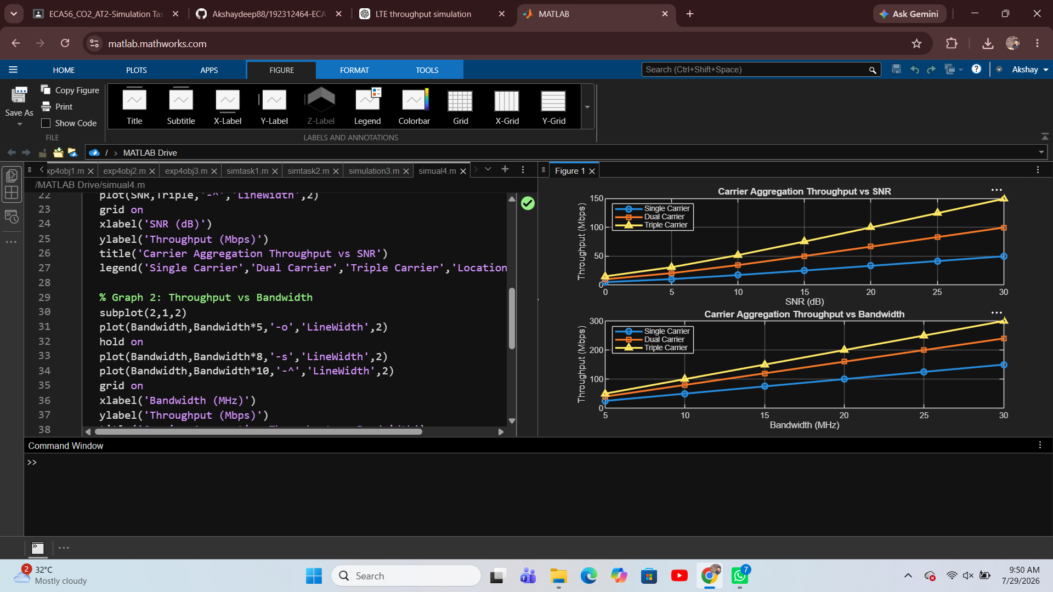

Result:
The MATLAB simulation was successfully completed. The graphs show that throughput increases with increasing SNR and bandwidth, and triple carrier aggregation provides the highest throughput compared to dual and single carrier aggregation.

Simulation Task5: Simulation of MU-MIMO Throughput Comparison
Aim: To simulate the performance of MU-MIMO under varying user count, antenna count, SNR, modulation, and interference using MATLAB.
Program:
clc;
clear;
close all;

% MU-MIMO Simulation

Users = [5 10 15 20 25 30];
SNR = 0:5:30;

% Throughput vs User Count (Mbps)
Tx2 = [20 35 48 58 65 70]; % 2 Antennas
Tx4 = [30 50 68 82 92 100]; % 4 Antennas
Tx8 = [40 65 88 108 122 135]; % 8 Antennas

figure;

% Graph 1: Throughput vs User Count
subplot(2,1,1)
plot(Users,Tx2,'-o','LineWidth',2)
hold on
plot(Users,Tx4,'-s','LineWidth',2)
plot(Users,Tx8,'-^','LineWidth',2)
grid on
xlabel('Number of Users')
ylabel('Throughput (Mbps)')
title('MU-MIMO Throughput vs User Count')
legend('2 Antennas','4 Antennas','8 Antennas','Location','northwest')

% Graph 2: Throughput vs SNR
subplot(2,1,2)
plot(SNR,8*log2(1+10.^(SNR/10)),'-o','LineWidth',2)
hold on
plot(SNR,10*log2(1+10.^(SNR/10)),'-s','LineWidth',2)
plot(SNR,12*log2(1+10.^(SNR/10)),'-^','LineWidth',2)
grid on
xlabel('SNR (dB)')
ylabel('Throughput (Mbps)')
title('MU-MIMO Throughput vs SNR')
legend('Low Interference','Medium Interference','High Capacity','Location','northwest')
Output1:

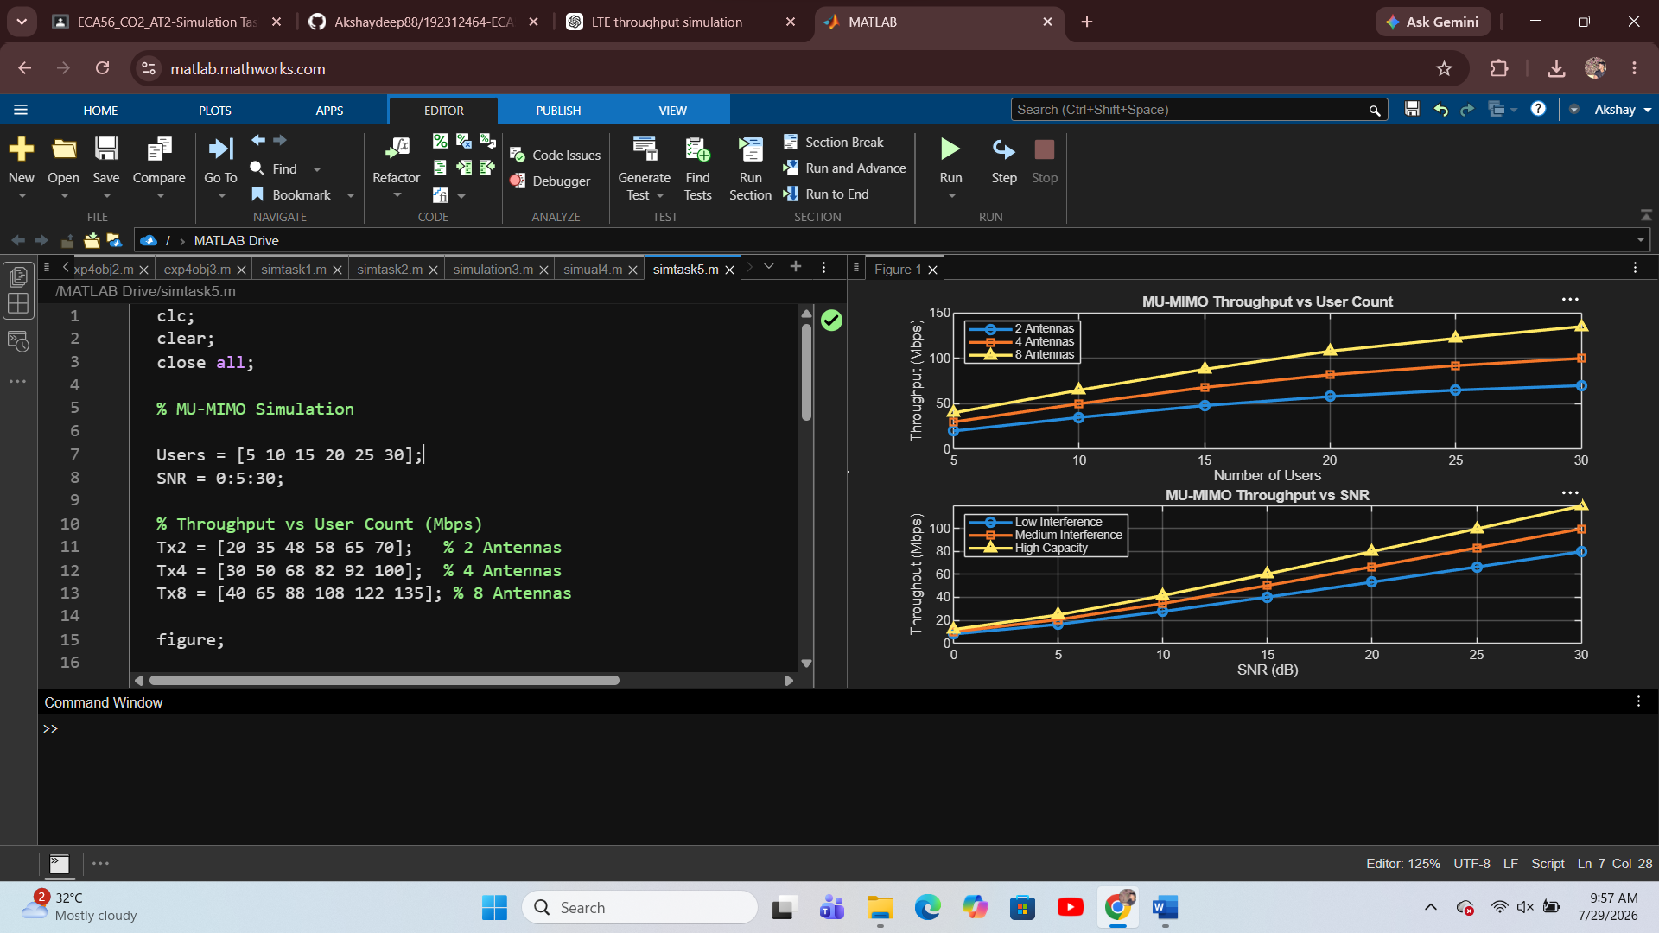

Result:
The MATLAB simulation was successfully completed. The results show that throughput increases with higher SNR and more antennas, while increased user count improves system capacity. MU-MIMO provides better overall network performance by serving multiple users simultaneously.

